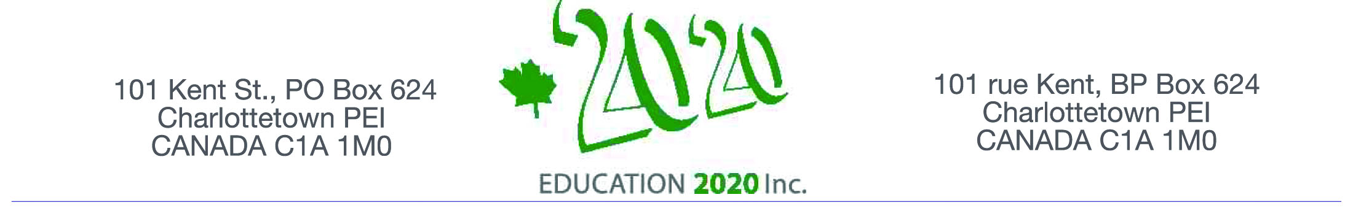 Education Engagement Award

Education, as compared to other sectors, lacks appropriate economic incentives for either the student, teacher, institution or the provider to provide a better product or service and do so ahead of schedule, however, there is increasing support for the view that incentives and awards help to improve student results; it is an award for having done something rather than a grant to help a school do something. In support of this view, The National Parent Teacher Association in the USA, makes awards to schools that demonstrate I high level of engagement because, they point out “when families, schools, and communities work together,
  - Student achievement improves,
  - Teacher morale rises,
  - Communication increases”

Proposal

Education 20/20 Inc. shares the view on the importance of engagement and the value of recognition, and is instituting an awards program as a mechanism to call attention by the public to important characteristics of effective schools and to provide some financial support to schools for their efforts to implement them. For the purpose of the award, the following five areas of engagement will be considered:
- student to student engagement,
- student to teacher engagement,
- student to learning materials,
- student to community partnerships, and
- parental involvement in schools.
Criteria
The focus of the award is on engagement in the daily operation of the school and only those items over which the school has substantial control such as:

- communication with family, culture, community
- frequency of community based events
- parent/community involvement in curriculum development and planning

Nomination process
Education 20/20 plans to call for nominations on January 30th, with a closing date March 29th, 2014. Nomination packages will be distributed on request. An Awards Committee will be established to review nominations and recommend a recipient; decisions will be made solely on the basis of information presented. Award will be given early May of 2014.

Further information: Contact Education 20/20 Inc. at above address

